H.T No
Regulations:
A18

Sreenidhi Institute of Science and Technology
(An Autonomous Institution)
Code No: 7A820 Date: 22-Dec-2022 (AN)

B.Tech III-Year II- Semester (A18) Special Supplementary Examination - December-2022
ELECTRICAL DISTRIBUTION SYSTEMS (EEE)

Time: 3 Hours Max.Marks:70

Note: a) No additional answer sheets will be provided.
b) All sub-parts of a question must be answered at one place only, otherwise it will not be valued.
c) Missing data can be assumed suitably.

ANSWER ANY 5 OUT OF 8 QUESTIONS. EACH QUESTION CARRIES 14 MARKS.

Bloom's Cognitive Levels of Learning (BCLL)
Remember | L1 | Apply | L3 | Evaluate | L5
Understand | L2 | Analyze | L4 | Create | L6

 |  |  | BCLL | CO(s) | Marks
1. | a) | Explain how the electrical loads are classified? | L2 | CO1 | [7M]
 | b) | Derive the relation between load factor and loss factor. | L3 | CO1 | [7M]
2. | a) | Compare the radial, loop and network type primary distribution feeders based on load, reliability of supply and economy. | L2 | CO2 | [7M]
 | b) | Discuss the factors affecting the loading of a primary distribution feeder. | L2 | CO2 | [7M]
3. | a) | Explain the different factors to be considered to decide the ideal location for a substation. | L2 | CO3 | [7M]
 | b) | Compare the % voltage drop of the feeders with square type service area and hexagonal type service area. | L2 | CO3 | [7M]
4. | a) | Derive an expression for voltage drop and power loss for uniformly radial type distribution load. | L2 | CO4 | [7M]
 | b) | Consider a 3-Ø, 3-wire 240V secondary system with balanced loads at A, B and C as shown in Figure (1) Determine:  (i) The voltage drops in one phase of lateral  (ii) The real power per phase for each load  (iii) The reactive power per phase for each load.  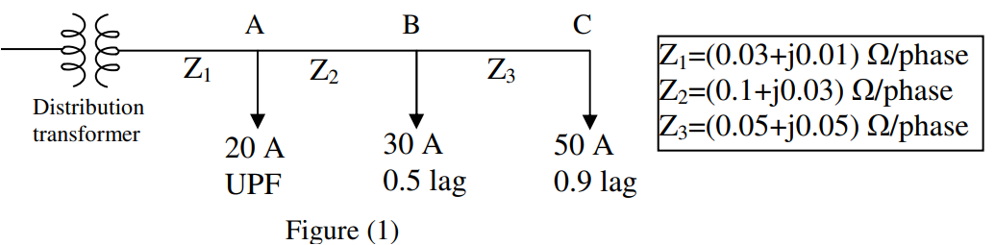 | L3 | CO4 | [7M]
5. | a) | Explain the procedure for coordination between reclosure and circuit breaker. | L2 | CO5 | [7M]
 | b) | What is the need for coordination of different protective devices? Explain in detail. | L2 | CO5 | [7M]
6. | a) | Explain the function of line drop compensator on voltage control. | L2 | CO6 | [7M]
 | b) | A 3-Ø 400 HP, 50Hz, 11KV star connected Induction motor has a full load efficiency of 88% at lagging power factor of 0.78 and is connected to a feeder. If it is desired to correct the power factor of 0.92 lagging load, determine  i) The size of the capacitor bank in KVAR  ii) The capacitance of each unit if the capacitors are connected in delta as well as in star. | L3 | CO6 | [7M]
7. | a) | What are the factors affect the distribution system planning? | L2 | CO1 | [5M]
 | b) | Write short notes on types of distribution feeders. | L2 | CO2 | [5M]
 | c) | Explain how to decide the rating of a distribution substation. | L2 | CO3 | [4M]
8. | a) | A 3-Ø, 11KV, 30MVA generator with X₃ = 0.06 PU, X₁ = 0.3 U and X₂ = 0.3PU is grounded through a reactance of 0.28Ω. Calculate the total fault current for a Single line to Ground fault. | L3 | CO4 | [5M]
 | b) | Explain the coordination procedure between fuse and circuit breaker. | L2 | CO5 | [5M]
 | c) | How an AVB can control voltage? With the aid of suitable diagram explain its function | L2 | CO6 | [4M]

-- 00 -- 00 –

